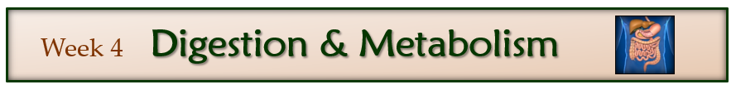***The activities listed in this Study Guide will help guide you through the Week 04 Study materials. The preparation and activities need to be completed prior to the first deadline and before taking the weekly quiz.***

***The reading materials, videos, and website links are posted in I-Learn, W04 Study.***

**Preparing for quizzes and tests:**

* Please note that the study guides are provided to establish a baseline understanding of the lesson materials. They can help you to organize your notes and prepare for quizzes and tests. You will find that the quizzes and tests do not have questions that come directly from the study guides but will build on the concepts you are learning. These assessments will require you take the knowledge and skills you have gained and apply them to real life problems and situations.
* To increase your proficiency:
  + To practice real life skills this week, try explaining to someone the entire process of digestion from start to finish. Include the vocabulary words from this week.

**This week’s goals:** The process of nourishing your body involves consuming, digesting, absorbing, and metabolizing the nutrients in food. This week we will explore the interaction of food in the digestive system and how the energy nutrients are metabolized in the cells.

**1. Digestion**

**From the reading *4.1 The Organization of the Human Body, 4.2 Digestive System Overview,* and the video *Action of an Enzyme*:**

* Describe the difference between cells, tissues, organs, and organ systems.
* What is the difference between chemical digestion and mechanical digestion?
* What is the function of digestive enzymes?

**Terms to Know**

Cell

Tissue

Organ

Organ system

Gastrointestinal Tract

Lumen

Chemical Digestion

Enzyme

Mechanical Digestion

Peristalsis

**From the video *Digesting Food*, the Digesting Food Notes Page (see next page), and the reading *4.3 Digestion and Absorption*:**

Know the following digestive enzymes, where they are secreted from, and what they break down.

|  |  |  |
| --- | --- | --- |
| **Digestive Enzyme** | **Secreted from** | **What breaks down** |
| Amylase |  |  |
| Pepsin |  |  |
| Lipase |  |  |
| Proteases (trypsin, chymotrypsin) |  |  |

Know the following secretions, where they are secreted from, and their function.

|  |  |  |
| --- | --- | --- |
| **Secretion** | **Secreted from** | **Function** |
| Saliva |  |  |
| Hydrochloric acid |  |  |
| Bile |  |  |
| Bicarbonate |  |  |

***Digesting Food* Video Notes Page**

Identify where the following items are located/produced on the picture of the human body, the small intestine, villus, and enterocyte.

Mouth

Salivary glands

Amylase (2 places)

Epiglottis

Esophagus

Lower esophageal Sphincter

Stomach

Lipase (3 places)

Hydrochloric acid

Pepsin

Chyme

Pyloric sphincter

Duodenum

Liver

Gallbladder

Bile

Pancreas

Trypsin

Chymotrypsin

Jejunum

Ileum

Ileocecal valve

Large intestine

Rectum

Anus

Villi (Villus)

Enterocyte

Microvilli

Blood Capillary

Lacteal

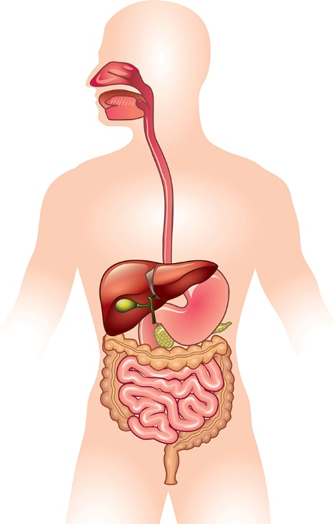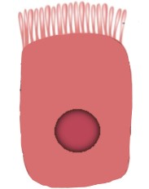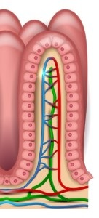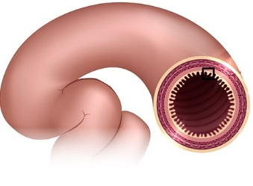

Know the following sphincters, where they are located, and their function.

|  |  |  |
| --- | --- | --- |
| **Sphincter** | **Location – what two organs does it connect?** | **Function** |
| Lower esophageal sphincter |  |  |
| Pyloric sphincter |  |  |
| Ileocecal valve |  |  |
| Anus |  |  |

Know the following parts of the digestive tract, where they are located, and their function.

|  |  |
| --- | --- |
| **Parts of Digestive Tract** | **Function** |
| Mouth* |  |
| Pharynx* |  |
| Epiglottis* |  |
| Esophagus* |  |
| Stomach* |  |
| Duodenum |  |
| Jejunum |  |
| Ileum |  |
| Large intestine* |  |
| Rectum* |  |

*\*Be able to identify where this item is located when given an image of the body*

Know the following accessory organs, where they are located, and their secretions.

|  |  |
| --- | --- |
| **Accessory Organ** | **Secretions** |
| Salivary glands* |  |
| Pancreas* |  |
| Liver* |  |
| Gallbladder* |  |

*\*Be able to identify where this item is located when given an image of the body*

**Terms to Know**

Chyme

Bile

Villi

Microvilli

Enterocyte

Lacteal

Blood capillary

**2. Absorption**

**From the reading *4.4 Nutrient Absorption and Delivery*:**

* What is absorption?
* Where do the water-soluble nutrients (sugars and amino acids) go after absorption into the mucosal cells?
* Where do the fat-soluble nutrients go after absorption into the mucosal cells?
* What is the difference between passive diffusion, facilitated diffusion, and active transport?
* What happens to undigested substances that are not absorbed in the small intestine?

**Terms to Know**

Passive diffusion

Facilitated diffusion

Active transport

Blood capillary

Lacteal

Lymph system

**3. Metabolism**

**From the video Basics of Metabolism, and the reading *4.5 Metabolism*:**

* Where is acetyl-CoA formed?
* What nutrients can be made into acetyl-CoA (refer to *Basics of Metabolism* video)?
* Where in the cell do the citric acid cycle and electron transport chain take place?

**Terms to Know**

Catabolism

Metabolism

Anabolism

Cellular respiration

ATP

Acetyl-CoA

Citric acid cycle

Electron transport chain

**4. GI Health and Disorders**

**From the reading *4.6 Digestive Health and Disorders* sections: *Food Allergies*, *Celiac Disease*, *Gastroesophageal Reflux Disease*, *Peptic Ulcers*, and *Irritable Bowel Syndromel*:**

* What are the eight common food allergies?
* What is celiac disease?
* What foods need to be avoided by a person with celiac disease?
* Think it through: *Should everyone follow a gluten-free diet? Why/Why not.*
* What is GERD?
* What are the dietary recommendations for GERD?
* What is irritable bowel syndrome?
* When would a FODMAP diet be recommended?

**From the web page *Prebiotics and Probiotics: Creating a Healthier You,* and the reading *4.6 Digestive Health and Disorders* the *Probiotic* section: What is a probiotic?**

* What is a probiotic?
* What are some good food sources for a probiotic?
* How might probiotics benefit digestive health?
* What are good food sources for a prebiotic?

**Terms to Know**

Gut microbiota

Probiotic

Prebiotic

**5. Complete the Case Study**

Complete the *Case Study – Andrew and Digestion* posted in I-Learn, W04 Case Study: Digestion. Then answer the following questions/items and have your responses available when you take this week’s quiz.

* What are the common causes of constipation? (refer to the National Institute of Health’s webpage—Constipation: Symptoms and Causes of Constipation – review all pages)
* How might constipation be prevented and treated?
* What happens to food substances that are not absorbed?
* What recommendations would you give to Andrew regarding:
  + Ways to alleviate his constipation
  + How to prevent constipation in the future
  + Results of swallowing gum